# **Overview**

**Our team:**

* Tansu Sagidullayeva, 204094, [204094@astanait.edu.kz](mailto:204094@astanait.edu.kz), project: body and css, design, documentation: content structure (Site map, Content types, Design).
* Danira Beibit, 204040, [204040@astanait.edu.kz](mailto:204040@astanait.edu.kz), project: javascript, express, documentation: project goals and team interests.
* Raushanbekova Maira, 204067, [204067@astanait.edu.kz](mailto:204067@astanait.edu.kz), project: body, footer with contacts, documentation: content structure (Functionality, Hosting, Accessibility, deadlines).
* Asylbek Kozhakhmetov, 204147, [204147@astanait.edu.kz](mailto:204147@astanait.edu.kz) , project: javascript, express, documentation: content structure (Site map, Content types, Design).
* Aizhan Saduakas, 204032, [204032@astanait.edu.kz](mailto:204032@astanait.edu.kz), project: header with a navigation bar, body, footer with contacts, documentation: overview and summary.

**Communication strategy:**

* meeting and brainstorming minutes
* brief summary of the project analysis
* approaches for achieving objectives
* messages to encourage desired change
* communication channels to messages
* implementation plan
* monitoring

**Motivation:**

Building a well-designed football game website will help involve more people of all ages in this great sport. Due to the pandemic, most people cannot play offline however, we provide good opportunities to play online and demonstrate their skills.

**High-level project scope:**

It is a brand-new website for people who want to play football online

**Target audience:**

This website is targeted at guests around the world.

# **Project goals and team interests**

**Project goals:**

* Get an idea of the overall atmosphere of the football.
* Increase the population who interested in football.
* Increase the football popularity by 10%.
* Enjoy game.

**Team interests:**

* Practice knowledge of HTML tags, CSS, CSS Grid Bootstrap, JavaScript, express skills by building a website game.
* Establish a solid understanding of website design principles.
* Improve team working skills by collaborating with different members of the group.
* Scheduling the project and providing time estimates.
* Coordination of joint work of other team members.
* Planning out and task allocation.
* Understand better HTML and CSS by creating this website.
* Be a good web development team.

**Team interests:**

* Practice knowledge of HTML tags, CSS, CSS Grid Bootstrap skills by building a beautiful canteen website.
* Improve team working skills by collaborating with different members of the group.
* Scheduling the project and providing time estimates.
* Coordination of joint work of other team members.
* Planning out and task allocation.
* Be a best web development team.

# **Phases**

* Phase 1 – Basic game website with HTML
* Phase 2 – Add styles to improve the appearance and thus draw wider audience
* Phase 3 – Incorporate a JavaScript (game working).
* Phase 4 – Build a server using express.js.

# **Content structure**

**Site map**

This diagram shows the hierarchical structure of the website pages.

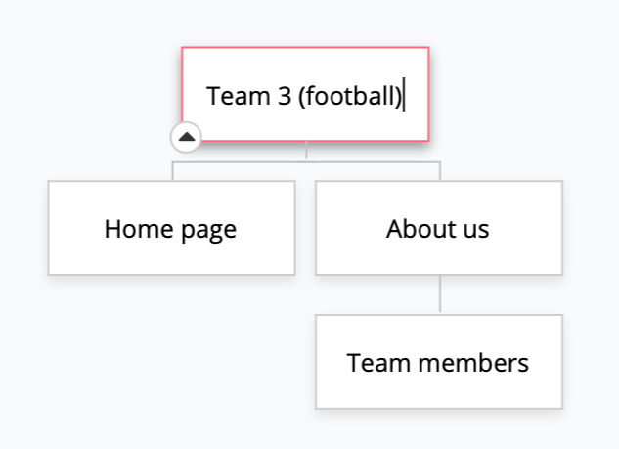

**Content types**

Since this is game website, it contains playing field. There is a separate page about creators. Contact information: Instagram, 2gis, university website.

Main content types:

* Home
* About us

**Design**

**Reference links**

* **Images**

1. <https://www.5stardesigns.co.uk/5star/county/swapmeet19/SM19-397/11.jpg>

Assets folder:

1. aitu-logo.png
2. aitu-logo2.png
3. Carousel1.jpg
4. Carousel2.jpg
5. Carousel3.jpg
6. Carousel4.jpg
7. Carousel5.jpg

* **Fonts:** <https://fonts.google.com/specimen/Raleway?preview.text_type=custom>

**Bootstrap**: <https://getbootstrap.com/>

**CSS-tricks**: <https://css-tricks.com/>

**W3SCHOOLS:** <https://www.w3schools.com/>

**PALETTON:** <https://paletton.com/#uid=1000u0kllllaFw0g0qFqFg0w0aF>

**EXPRESS:** [**https://developer.mozilla.org/en-US/docs/Learn/Server-side/Express_Nodejs/Introduction**](https://developer.mozilla.org/en-US/docs/Learn/Server-side/Express_Nodejs/Introduction)

**SERVER:** [**https://www.digitalocean.com/community/questions/connect-to-http-localhost-3000-with-nodejs-app-connection-refused**](https://www.digitalocean.com/community/questions/connect-to-http-localhost-3000-with-nodejs-app-connection-refused)

**Functionality**

This website is built according to web standards, it has a well-programmed design in 4 colors. ‘Sans serif’ font used, some people find it difficult to read serif fonts because they distract the eyes and the brain from the overall shape of the letter. It must work quickly and correctly, which helps to build a positive first impression. Also, this website has the possibility of playing with another team. We also use our knowledge from lectures about Node.js, Express, js and JavaScript functions, arrays, and so on.

The website is optimized for smartphones, which is also a very convenient advantage since most visitors do not use personal computers, and use phones, and the optimization makes them available at anytime, anywhere.

**Hosting**

The following steps were required to host the website. Firstly, we installed node js on the PC. The next step was to choose a working js file and run the server localhost 3000.

**Accessibility**

The website is accessible to everyone, as anyone from anywhere can access it from any convenient gadget. ‘Sans serif’ font used: “Sans serif” means “without the decorative line”. Some people find it difficult to read serif fonts because they distract the eyes and the brain from the overall shape of the letter. We did not animate text and avoid making the letters flash or blink, so it will not cause any difficulties to read. All content is organized with convenience, the navigation bar is fixed, which does not force the user to scroll the screen every time, and the navbar has all the necessary buttons to go to the desired page.

**Deadlines**

* Phase 1 – March 14.

We divided the responsibilities among ourselves and determined who performs what role in the construction of the website. After that, we started to work on their part of the task.

* Phase 2 – March 15.

We followed guidelines, created HTML (homepage, header, footer, menu, reservation page) and CSS file (found all info that would be added to the site (came up with a color scheme, selected the necessary fonts)). We started working on JavaScript.

* Phase 3 – March 16.

We continue working on JavaScript. Editing HTML and CSS files.

* Phase 4 – March 17-18.

The website has acquired a final appearance, the final touches have been done, and all errors have been fixed.

# **Summary**

After completing the creation of this site, we took a great experience for ourselves and took a step towards creating websites, as we used important aspects covering the studied material over the past ten weeks. It also strengthened our CSS, HTML, and JS skills. Working in a group helped us to become more cohesive and forced us to get out of our comfort zone, we defined a clear task and correctly set goals, taking into account the thoughts, ideas, and opinions of each member of the team. The website turned out to be more interesting, as it was made by the team, all suggestions were taken into account, which helped to invest maximum effort. Every detail was worked out, the images were selected by the theme, visually pleasing fonts, and color combinations that will appeal to the site visitor. The interface has been designed to be as user-friendly as possible and optimized for any type of gadget, which makes the use of the site easier. In general, the work was very interesting and informative, we applied our skills in a stressful situation and went out of our comfort zone.